Name: Linus Reynolds

Period: 3

Activity 1.1.3 Fun with Flowers and 1.1.4 Spinning with Spirographs

# 1.1.3 Fun With Flowers

PLTW is having you use common coding techniques without stopping to slowly explain some of the details of what is going on. I think that's ok, because most of you probably intuitively know how the things work (until you run into a problem). Be sure to make a note of any questions you have and ask your partner and if you both aren't sure, ask me. I'd be happy to explain the concepts and illustrate them with examples.

The main skills involved in this activity are using the while and if control structure and branching structures. Related to both of these is the idea of a conditional statement (often referred to in shorthand as just a conditional or condition) which is something that evaluates to True or False.

Log in to 1.1.3 and do the activities. Be sure you understand how to use the modulus operator.

21. Paste a snip of your python code that makes at least three buildings of no more than 21 floors each. The pattern for each building is three floors of one color, then three floors of another color, and then three more floors of a third color…and then the color pattern repeats. It should look like this, or it can have all 3 towers look identical in their striping of changing colors after every 3 floors:

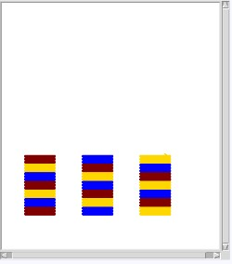

Snip your code in here:

|  |
| --- |
| import turtle as trtl |
|  |
| painter = trtl.Turtle() |
| painter.speed(0) |
| painter.pensize(5) |
|  |
| # starting location of the tower |
| x = -150 |
| y = -150 |
| newX = -150 |
|  |
| # height of tower and a counter for each floor |
| num_floors = 63 |
| floor = 0 |
| towerReset = 0 |
| # iterate |
| while floor < num_floors: |
| # set placement and color of turtle |
| painter.penup() |
| # detect if it's time for a new tower |
| if towerReset == 21: |
| newX = newX + 100 |

|  |
| --- |
| painter.goto(newX, -150) |
| x = newX |
| y = -150 |
| towerReset = 0 |
| else: |
| painter.goto(x, y) |
| # Choose color |
| if floor % 6 > 2: |
| painter.color("gray") |
| elif floor % 12 > 2: |
| painter.color("red") |
| else: |
| painter.color("blue") |
| y = y + 5 # location of next floor |
| # Add onto the floor number |
| floor = floor + 1 |
| towerReset = towerReset + 1 |
| #draw the floor |
| painter.pendown() |
| painter.forward(50) |
|  |
| wn = trtl.Screen() |
| wn.mainloop() |

Snip your output here:

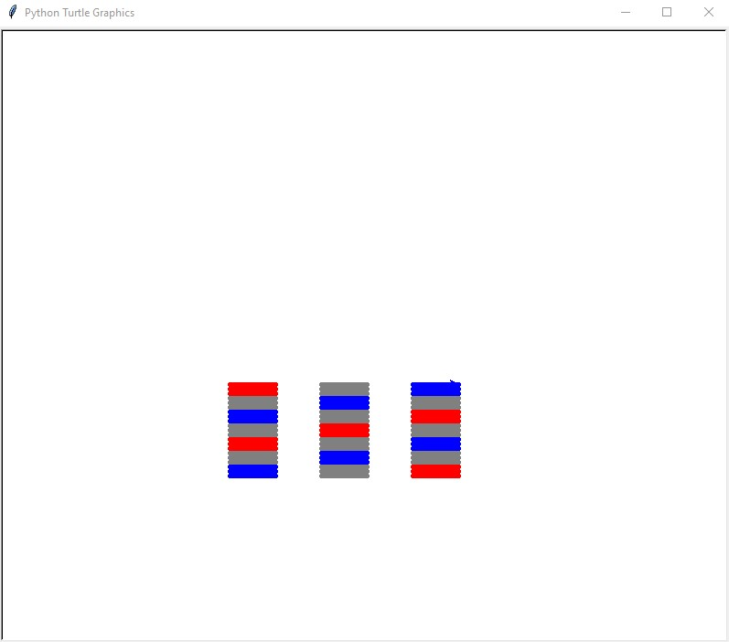

Be sure to save your program.

I'm not real keen on the example they provide in #22. You can skip over it.

C3. Explain in your own words how you used while loops in this activity.

I used while loops to loop the code that makes a floor while the number of floors is less than 63. I would rather use a for loop for this, but I used a while loop because that is what the activity said to do.

# 1.1.4 Spinning with Spirographs

Continuing on with while loops, and adding in some more dexterity with mathematical operations.

6. Paste a snip in or your code for this one. Don't forget to add your program docstring at the top and to save your file.

'''

|  |
| --- |
| ''' |
| Made by Linus Reynolds |
| On 9/23/2021 |
| 1.1.4 #6 |
| ''' |
|  |
| num1 = int(input("Please type in a number ")) |
| num2 = int(input("Type in another one. ")) |
| while(num1 % num2 != 0): |
| print("These numbers are not divisble! Please try again!") |
| num1 = int(input("Please type in a number ")) |
| num2 = int(input("Type in another one. ")) |
| print("They are divisible!") |
|  |

9b. Paste a snip of your code that makes this tighter spiral so that all 80 of the circles fit on your screen. Don't forget your program docstring and to save your file. (You can do whatever you'd like with the colors of the circles.)

|  |
| --- |
| ''' |
| Made by Linus Reynolds |
| On 9/23/2021 |
| 1.1.4 #9b |
| ''' |
| import turtle as trtl |
|  |
| # Sets up the turtle |
| painter = trtl.Turtle() |
| painter.speed(0) |
| painter.penup() |
| painter.color("salmon") |
| circleColor = "salmon" |
| painter.pensize(2) |
|  |
| # Sets the circle number |
| spiral_space = 0 |
|  |
| # Loops until there are 80 circles |
| while (spiral_space < 80): |
| # Makes circle |
| painter.goto(0,0) |
| painter.right(20) |

|  |
| --- |
| painter.forward(50+(spiral_space*1.5)) |
| painter.pendown() |
| painter.circle(10) |
| painter.penup() |
| spiral_space = spiral_space + 1 |
| # Decides color of circle |
| painter.color(circleColor) |
| if (spiral_space % 18 == 0): |
| painter.color("navy") |
| circleColor = "navy" |
| if (spiral_space % 36 == 0): |
| painter.color("salmon") |
| circleColor = "salmon" |
| if spiral_space % 5 == 0: |
| painter.color("green") |
| if spiral_space % 10 == 0: |
| painter.color("red") |
|  |
| wn = trtl.Screen() |
| wn.mainloop() |

Paste the output of your code, too.

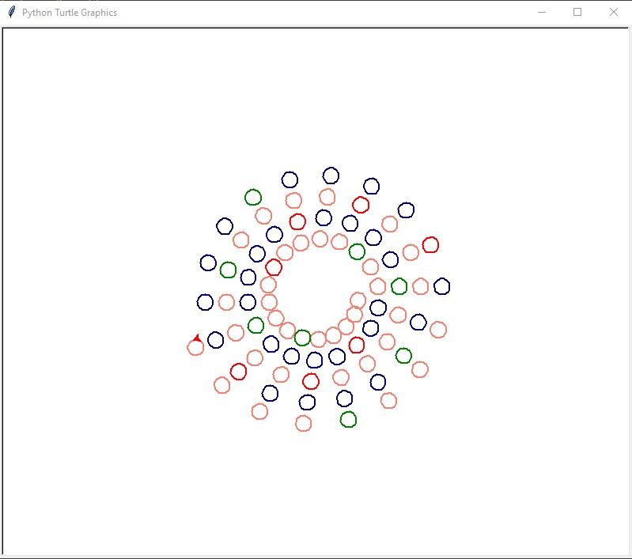

12-14. Paste your nested while loop (show both the inner and outer loops) for #14. You want your program to recreate the image they show for #14.

'''

Made by Linus Reynolds

On 9/23/2021

1.1.4 nested loop

'''

import turtle as trtl

# Sets up turtle

painter = trtl.Turtle()

painter.shape("circle")

painter.hideturtle()

painter.penup()

painter.speed(100)

# Makes drawing

x = -200

y = -200

while (y < 200):

    y = y + 50

    painter.goto(x,y)

    painter.color("red")

    painter.stamp()

    while (x < 0):

        x = x + 50

        painter.goto(x,y)

        painter.color("blue")

        painter.stamp()

    x = -200

wn = trtl.Screen()

wn.mainloop()

Paste a snip of your output

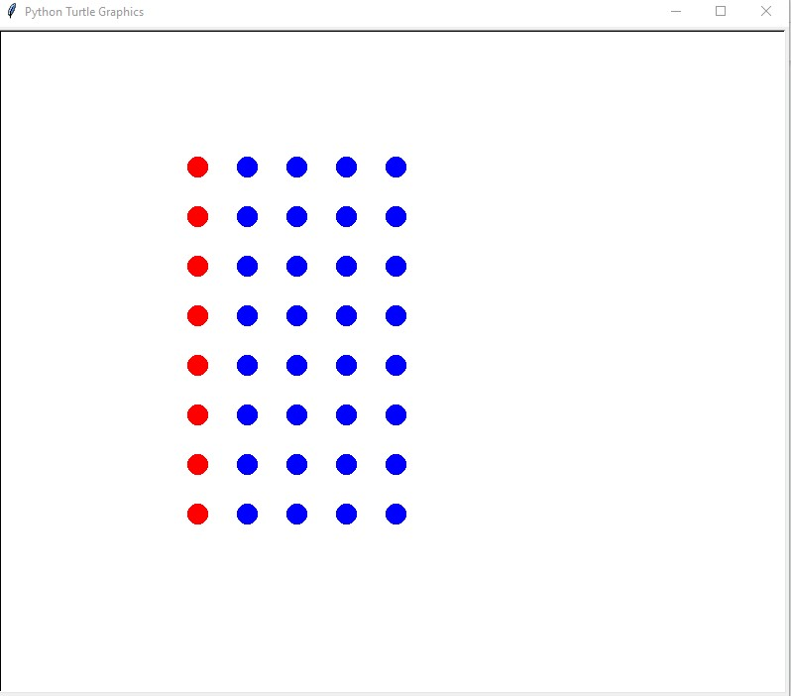

.

17. What one line did you have to change to make 2 mountains instead of one? Paste the line here: while (x < 1):

22. Draw a flow chart for the three towers problem (1.1.3 #21). You are welcome to draw it by hand, and attach the photo of it in here.

Hmm, I wonder if they are going to talk about for loops and else if (elif) and else statements next?